

Gender Directive 2004/113/CE:

Was it the right time to ban gender-based insurance pricing across the EU?

Authors:
Lionel TEXIER R&A Managing Director – ActuariaCnam founder
Magalie JOUSSET R&A Trainee – INSEEC Business School Paris Student
Roshni BHUDIA R&A Trainee - CASS Business School London Student



Credits © European Union 2013

Contact : contact@riskandanalysis.com

Table of Contents
Table of Contents 2
Abstract 3
Introduction 4
The Test-Achats case 4
The impact of the ban on gender-based pricing 6
Laws and regulations 8
EU Directive & Guidelines 8
UK Law & guidelines 10
France Law 13
Belgium Law & guidelines 18
Luxembourg Law project & guidelines 20
Is there a risk that the objective to create equality may actually lead to inequality? 22
Life insurance & Pensions 23
Prospective 23
Men and women lifespan are different across EU 26
About the complexity to forecast the evolution of men and women lifespan 29
The scope of the unisex pricing for pension 29
Conclusion 30
References 35

Abstract

In 2014, the European Commission will provide a report on the implementation of the Test-Achats case across the EU. The insurance industry has transformed due to digitalization and regulatory purposes like Solvency II, even during the financial crisis. This paper discusses the importance of the gender ban, and goes deeper into describing the implementation process of the Test-Achats case in different EU countries by analyzing some figures and predictions. Our findings have helped us make our own opinions about the following point: Was it the right time to ban gender-based insurance pricing across the EU?
In the first part we present the Test-Achats case and the chronology of events regarding the Gender Directive. Then, in this paper goes on analyse figures allowing us to make predictions about unisex pricing based on different sources in order to underline the difficulty to assess the real impact on the insurance products premium.
We thought it was important to show the heterogeneity of laws within the European Union. Thus, in the main part of this paper, we explain the European texts and guidelines for unisex pricing in the UK, France, Belgium and with Luxembourg national interpretations as well. It illustrates the difficulty to ensure the consistency between a common continental rules and a specific national applications.
We then go on to insurance specific properties and try to answer the question: Is there a risk that the objective to create equality may actually lead to inequality for insurance services?
Given the current changes concerning life insurance (since in non-life insurance some European countries used already unisex pricing before the 21st of December 2012), we dedicated that in this part of this paper we will provide an overview of the difference in life expectancy between women and men in the EU. We thought it was important to understand the diversity between populations and periods and the difficulty for demographers to predict its evolution on a long-term basis. Therefore, in this part we evaluate if it is statistically appropriated to consider female and male in the same way in terms of risk profile and insurance premium at the beginning of the 21st century across all European Union countries.
Finally we underline the difficulty to apply equality principles to insurance products. It is predicted that males and females will eventually have the same mortality levels on average. Before this time, there will be constant debates and contradictions between opinions and figures. We conclude this paper by an invitation to a global consideration of the equality principles versus the segmentation in insurance in a period of digital and biotechnologies innovation.

Introduction

The European Court of Justice (ECJ) announced in March 2011 that insurance companies are no longer permitted to charge men and women dissimilar premiums. Following this ruling, the Gender Directive was implemented on 13th December 2004, which was applied to the insurance industry in the UK on the 21st December 2007. However, the Directive was updated on the 21st December 2012, at the end of the opt-out for insurance products. Their intention is to provide fair treatment between men and women, disallowing any sexual discrimination in the supplying of goods and services across the European Union. The Gender Directive affects the insurance industry and private pensions and this applies to policies subscribed after 21st December 2012. It is quite surprising that 51% of women under 30 are unaware of the EU Gender Directive and 57% think it is not a fair law.
All 27 countries in the EU had obtained an opt-out (choosing not to participate in the legislation, allowing insurers to use gender as a rating factor) from the original Directive 2004/113/EC, which came into effect almost 6 years ago on 21st December 2007. Insurers were allowed to use gender in their calculations only with sufficient, reliable actuarial and statistical data as stated by the law. However, gender can be applied only in reinsurance pricing policies, marketing, advertising, underwriting for life and health and to those insurance products aimed specifically to men or women. Indirect discrimination using factors that are associated to gender may be allowed if the objective is “legitimate, the means of achieving it must be appropriate and necessary”. This result was studied until 21st December 2012 to ensure that the intention for the opt-out was with reason.

The Test-Achats case
Test-Achats is a Belgian consumer organisation that challenged the Gender Directive 2004/113/EC article 5(2) of the European Union. The European Court of Justice (ECJ) passed down its ruling on a case regarding a provision of the Directive. Insurers are required to derive premiums using gender related factors, without any sort of gender discrimination as an important right of the European Union, applying ethical treatment between men and women. There has been no appeal against this ruling.
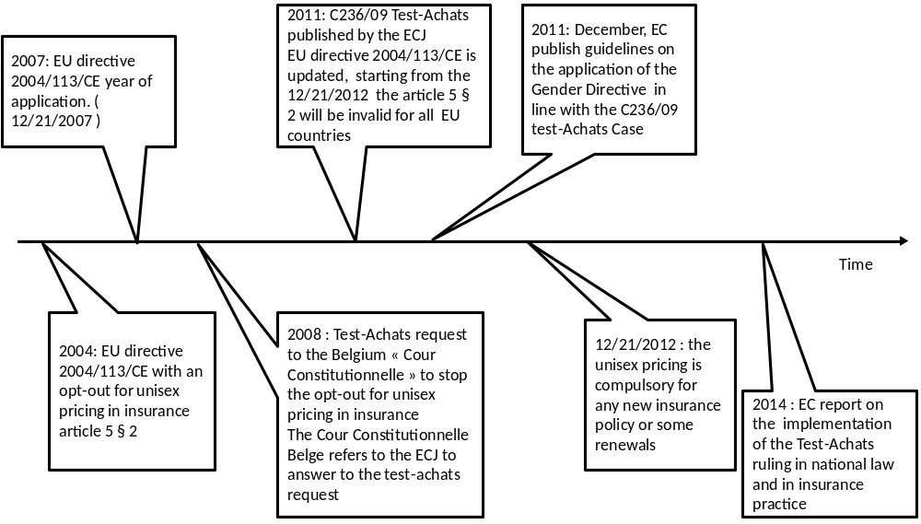

Figure 1: Timeline of the Gender Directive

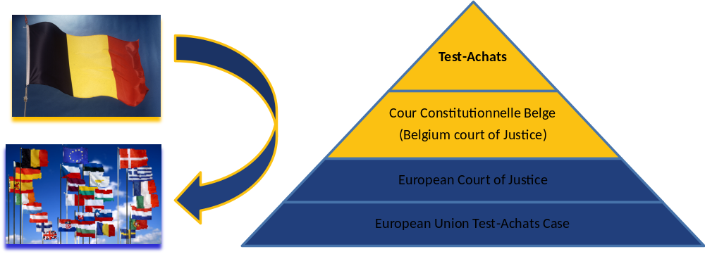

Figure 2 : The Test-Achats case, from Belgium to the EU - Credits © European Union 2013

Insurers must comply with the rules on the basis of gender ensuring that it is based on "relevant and accurate actuarial and statistical data" (section 13(3ai) e). The result of the decision was that insurance companies are no longer prohibited to support sexual discrimination in their policies after 21st December 2012. The ECJ stated that before this date, insurance companies were given a short period of time to prepare and adjust to this ruling. Now, insurance companies are no longer allowed to use gender as an influence in pricing premiums.

The impact of the ban on gender-based pricing

Since the implementation of the ban, at the end of last year, the impact has varied by insurance product. As it has only been a year following the gender ban, it is expected that figures will vary significantly since last December. However, annuity expert Steve Lowe from Just Retirement argued that rates will ‘become more robust’ over the period of the whole of the first quarter, when the ban was first launched. Neither of these arguments can be justified clearly so further analysis is required over several years.
EU rules have had an impact on insurance for men or women as gender discrimination is disallowed. So who has been impacted the most after this ruling? AA insurance premium index announced at the end of January 2013, that there was a 42% increase in the average best premium for 17- and 18-year-old female drivers since 1st December 2012, while premiums for 17 and 18-year-old males decreased by 17% in the same period.
Since this overruling, women have also faced higher life insurance premiums as previously, women on average benefited from higher life expectancy. Now, new premiums are said to fall close to both. On the upside, women on average are benefiting from lower premiums for insurance such as cancer cover and income protection.
A study from Oxera predicted that “men (aged 65) could see a reduction in pension income from pension annuities of around 5% or more, on average women (aged 40) could see life insurance premiums rise by around 30% or more, on average; young women (aged 20) could see motor insurance premiums rise by 11% or more on average”. This in turn, could have lead to unpredictable numbers of policy renewals before 21st December 2012. Therefore, insurance companies can use techniques of data analysis to understand how gender variations have been applied through factors such as sex and age to other factors such as women’s professions compared to men.
According to UK government figures, it is said that young women aged 25 are seeing a 24% increase in their car insurance premiums whereas women aged 30 are experiencing an increase of 9% on average. For men aged between 17 and 35 in the UK have on the contrary seen a fall in their premiums by 9% and a fall by almost 4.5% for 26 to 45 year olds. Compared to France, young women have seen a 3% increase and male drivers have seen a decrease of 13%. It is clear that young females are bearing the brunt of this new legislation for motor insurance and for this reason, it is important for men and women to take some financial advice on how the new law has been embedded to ensure that their insurance needs are met.
According to research undertaken by Tiger watch, the monthly car insurance observer has assessed the impact after the introduction of the EU Gender Directive. Car insurance prices in January, February, March and April were at -2%, +4%, +2% and 0% respectively. However, for female drivers at the age of 20, figures were +21%, +45%, +46% and +33% respectively in line with the UK government prediction. The trend in insurance pricing this year brings good news to motorists; as between April to June 2013 prices have been 3.1% cheaper than the start of the year.
This ruling that came in force at the end of last year has adopted risk based pricing. With this pricing method, underwriters assess the risks associated with the insured and their past history, using statistical and actuarial tables to present this information, estimating the likelihood and size of a claim. From this, they can determine which premiums to charge. There are major differences up to now for motor accidents, life expectancy and morbidity for both genders. Gender is used for accuracy of pricing premiums that cover these risks.
Pricing in the insurance industry is extremely important. If an insurance company sets low premiums for a risky consumer in a market where buyers and sellers have access to different information and resources, they employ a higher risk consumer group of which the policy is under-priced. This in turn, will reduce the insurance company’s financial stability. It is impossible to follow this ruling without occurring any costs. Since one group of consumers benefit from the ban, then it will always make the other group worse off. Eliminating gender based pricing requires removing gender factors in insurance pricing, but also rating factors from existing pricing models. This is very costly to apply and part of this cost will be transferred to clients through higher premiums, even if the concurrence may moderate this impact for clients.
Prices are purposely increased for the lower-risk gender. For example, for motor insurance, premiums have been increased for young women drivers to compensate the fall in premiums for young male drivers. The effects are greater if this new pricing policy influences the overall demand in the market in the future. The lower risk gender may opt out and the higher risk gender may opt in which in turn, will create more riskiness in the market. However, the impact will vary depending on different insurers, which will possibly make the market more competitive in the long run.
However, there is some Economic uncertainty over the gender-based pricing ban. In EU countries such as Greece and Italy who have faced great financial losses, this can raise a slight concern whether it was the right time for the Gender Directive. Millions of consumers have been hit hard by the recession, some having to sacrifice luxuries like having a car. This may demonstrate multiple effects on the economy and may affect the motor insurance industry. With more and more people unable to afford paying expenses, alongside increasing prices for motor insurance from the ban, insurance companies may suffer. Given the intense competition in European markets, it would take an enthusiastic insurance company to utilise the gender ruling in order to gain a competitive advantage. Those insurers at the same time want to capture a large proportion of market share but they have to be careful not to attract groups of higher risk consumers.
There has always been expected cost implications’ following this ban for the insurer as well as the insured. Insurance companies now have to invest their time and money into re-pricing, altering and printing of updated documents and training their staff as a result of the ban, of which these costs are passed down to the consumers as higher premiums. Now that the insurance regulations have become unisex, this raises the question if there is a future for such insurance companies targeting specifically men or women i.e. Sheilas’ wheels and Diamond, as targeting women may not be so unique anymore because they now pay the same premiums as male drivers. However, clever marketing techniques can be used to still appeal to the female consumers. Take the marketing strategy from ‘1st for women’ for example, a South African insurance company appealing to women. They effectively target the female market because in their advertisements, they convey the message that women are generally more responsible. If the UK insurance companies adopt third concept, they will have to eliminate the male consumers and purely target the female consumer base. Although they might lose out on the male consumers, they may grasp the attention of new female clients.
Such niche companies target women do not exclude men from purchasing insurance policies from these companies, especially if insurance premiums work out cheaper for the male consumer. Clever marketing tactics are used to attract a large female base of consumers. Such tactics include: Offering clothes shopping vouchers, free handbag or shoes with an insurance policy, advertising in female magazines, having only women to represent the company, continuously focusing on women rather than men.
Laws and regulations

EU Directive & Guidelines

The EU Directive
The EU 2004/113/CE article 5(2) invalidation through the C-236/09 Test-Achats Case:
“2. Notwithstanding paragraph 1, Member States may decide before 21 December 2007 to permit proportionate differences in individuals' premiums and benefits where the use of sex is a determining factor in the assessment of risk based on relevant and accurate actuarial and statistical data. The Member States concerned shall inform the Commission and ensure that accurate data relevant to the use of sex as a determining actuarial factor are compiled, published and regularly updated. These Member States shall review their decision five years after 21 December 2007, taking into account the Commission report referred to in Article 16, and shall forward the results of this review to the Commission.”
Therefore, the first paragraph must apply mandatory:
“1. Member States shall ensure that in all new contracts concluded after 21 December 2007 at the latest, the use of sex as a factor in the calculation of premiums and benefits for the purposes of insurance and related financial services shall not result in differences in individuals' premiums and benefits.”

The EU Guidelines:
The contracts concerned are:
- Contracts concluded for the first time as from 21 December 2012. Therefore, offers made before 21st December 2012 but accepted as from that date will need to comply with the unisex rule
- Agreement between parties, concluded as from 21 December 2012, to extend contracts concluded before that date which would otherwise have expired (a contractual agreement requiring the expression of consent by all parties is made)

Gender-related insurance practices, which remain possible:
It is still possible to collect, store and use gender data for:
- Reserving and internal pricing
- Reinsurance pricing
- Marketing and advertising
- Life and health underwriting (physiological differences between men and women for instance for some cancer like breast or uterus cancer)
- Excluding the pregnancy and maternity risk (see the specific solidarity mechanism created by article 5(3)), and under the conditions of the article 4(5), it is possible to offer gender-specific insurance products (or options within contracts) to cover conditions, which exclusively or primarily concerns males or females (prostate cancer, uterus cancer, breast cancer…)
- Using risk factors which might be correlated with gender as long as they are true risks factors in their own right (for instance the size of a car engine)

Scope of the Directive:
The Directive only covers insurance and pension, which are private, voluntary and separate from the employment relationship (it excludes group health and accident contracts and occupational pensions covered by Directive 200/54/EC).

Monitoring of the guidelines:
The commission will:
- Make sure that all the EU member states comply to the Directive and the guidelines starting from the 21st December 2012 by adapting their legislation
- Remain vigilant to detect any unjustified rise in prices or anti-competitive conduct
- Report on the implementation of the Test-Achats ruling in 2014

Now we know the EU law and guidelines, we will see the way it was implemented in the UK, France, Belgium and Luxembourg in order to get an idea of the consistency across some EU countries.
Article 6 of the Treaty on European Union preserves the fundamental right of equal treatment between men and women into European Union law by recognizing the Charter of Fundamental Rights of the European Union and giving it legal validity. The Charter of Fundamental Rights prohibits discrimination by gender and directs that “equality between women and men must be ensured in all areas.”
To implement this fundamental right of equal treatment the 2004 Gender Directive (2004/113/EC) prohibits discrimination based on sex in access to, and supply of, goods and services. The Gender Directive has been transposed into UK law by the Equality Act 2010.

UK Law & guidelines

In the UK, the Gender Directive 2004/113/CE was implemented into the law by the Sex Discrimination Act 1975 (Amendment of Legislation) Regulations 2008, which is an update of the ‘Sex Discrimination Act 1975 (Amendment) Regulations 2003’. The older legislation took no account of discrimination against gender. The 2008 regulations will no doubt be revised to reflect the European Court's decision. Allowing EU insurers to use gender-based factors for pricing was introduced to UK law, chapter 3 - equality of terms (part 5), of the ‘Equality Act 2010’ (provided that any equality is based on actuarial or statistical data).
One of the changes made to the new 1976 UK legislation is to empathize more on eliminating gender discrimination for insurance in the provision of goods and services. The amendment has made clear that sexual harassment and gender discrimination is disallowed to the provision of goods and services.
Additionally, it is essential for insurance companies to state the proportional differences in consumers’ premiums and their benefits as a result of the Gender Directive. Then, the differences must be defined using significant and correct data. This data must be frequently updated and improved, then printed to meet these new regulations.
The Gender Directive disallows sex discrimination such as discrimination against men and women, discrimination against women who are pregnant or on maternity as well as discrimination against transsexual people. Regarding pregnancy and maternity, since the gender ruling, it is now unlawful for insurance companies to treat women in a different manner if they are pregnant or concerning maternity in providing goods and services. There is no exception that relates to the use of actuarial and statistical data and thus, the constraint is unchanged by the decision in the Test-Achats case.
The Official Journal of the European Union underlines the Directive specifications, which is the same for all 27 EU member states. However, what may differ is individual country laws and legislation.
UK Law: Only repeal paragraph 22 of the schedule 3 with effect from 21 December 2012
The UK Government response to the insurance industry consultation
The UK government’s response to the consultation launched in December 2011 by the HM Treasury gives some explanations. Globally, it refers to the ECJ future decisions regarding the right or wrong application of the European text by the insurance industry. Sometimes it confirms insurers’ interpretation of the EU guidelines and sometimes it does not take position and invite the insurance companies to obtain their own legal advice.

We underline some key points below based on our read of the document:

Indirect discrimination
Regarding the indirect discrimination, (ultimately insurers will need to seek legal advice and make their own assessment of which risk factors they are content to continue to use after 21 December 2012) the government will not give more guidance to support insurers in their choice of risk factors used to calculate their premium.

Collection of data and use in assessing overall risk or marketing and advertising

It makes clear that it is still possible to collect gender data and for instance to use the gender-mix to assess the overall risk presented by the pool.
However, even for EU Guidelines, it is possible to use gender for marketing and advertising. Insurance companies should not practice unlawful target selling at one gender for instance (it must not give the impression that under certain circumstances, insurance would not be provided to the other gender), because they must comply with the UK Equality Act in the same way before and after the 21st of December 2012.

Definition of a new contract

The HM Treasury underlines that the definition of a new contract is an area of possible divergence of interpretation by the insurance companies especially for the treatment of automatic extensions to an existing contract (tacit renewals). Therefore, it recommends referring to the national law on automatic extensions since it should be a more risk-averse approach and would help to minimize the risk off successful legal challenge. Under certain circumstances, it recommends to obtain legal advice for this specific purpose.

Group insurance schemes and work-based pension schemes

Paragraph 20 of schedule 3 of the Equality Act will not change and there is no question from the insurance industry about that. An employer may continue to use gender-based price for group insurance schemes, which provide benefits to its employees.
The HM Treasury document refers to the guidance from the European Commission which suggests, “where an annuity purchased using funds held in a work-based pension scheme is purchased without the involvement of the employer or the scheme, the purchase would fall within the scope of the Gender Directive (implemented by part 3 of the Equality Act)”.
The government notes the requirement to provide gender-neutral pricing of annuities to work-based pension arrangements as well as personal pensions in order to prevent any overall consumer detriment. It keeps this issue under review and monitors carefully the impact the ECJ judgment on the annuities market to consider any further actions may be appropriate at this stage.

Other comments and conclusion

It is interesting to highlight some common sense conclusions from the HM Treasury, which may lead to good decisions based on the future interaction between the UK insurance industry and their national supervisor and the UK government with the European Commission and ECJ:
“We are conscious that many of the issues involved in the interpretation of the judgment are complex and we judge that it may take time for a common interpretation to emerge. Only the courts can provide an authoritative interpretation of the judgment and additional guidance from the Government would not help to minimize the risk of legal challenge to insurance providers. Finally we intend to continue to work closely with industry during the transition to gender neutral pricing and would appreciate further feedback from insurers and consumer groups on initial observations after 21 December 2012. We also intend to continue to engage with the European Commission to discuss whether and how further clarity can be provided on the application of the Gender Directive”.

France Law

The France law
In France, law number 2007-1774 of 17 December 2007 covers numerous provisions on economic and financial grounds. It underlines how discrimination is prevented for certain types of insurance groups and implements particular insurance arrangements of Article 5 of the Directive 2004/113/CE (see Article L.111-7 ‘Code des assurances’).
We underline there are three different legislations for the insurance industry in the country. Indeed, by depending on the legal structure of the insurance company (mutual insurance, insurance company or protection institution), it complies with the ‘Code de la Mutualité’, the ‘Code des Assurances’ or the ‘Code de la Sécurité Sociale’. But when the French Treasury changes the law, it is inverted in a consistent way through those three legislations. We will focus on the ‘Code des assurances’ change even if it is possible to know how the ‘Code de la Mutualité’ and ‘Code de la Sécurité Sociale’ change in the ‘Journal official’ publication. All the insurance companies, whatever their legal structure are supervised by the same institution: the ACPR.
A decision made by the ECJ banned any discriminatory actions and forced French insurance companies to apply an equal rate to those insured, regardless of gender, by the end of December 2012. The Test-Achats case has been inverted in France through the ‘Arrêté du 18 Décembre 2012’.
This ‘Arrêté’ was initiated in 2012, a new article into the ‘Code des Assurances’. Article A.111-6 defines the scope of the unisex rule in terms of ‘new contract'. The articles L.111-7, A.335-1 are modified.
Regarding life insurance, the mortality table used to define the premium must be at least the most prudent between the official female/male mortality tables provided by the French Institute of Statistics (INSEE) given the guarantee.
For instance if we consider a death cover, that means at least the premium would not change for males while the premium for females would become the same as for males and therefore increase. An insurance company still can define a specific unisex mortality table. Meanwhile, it must be certified by an accredited actuary, validated by the supervisor and it must be more prudent than the INSEE tables.
We also remark that the French law also mentions that insurance companies must payback at least 90% of the technical profit to policyholders. For instance, if one year there are less death claims benefits than expected in the premium, the insurer will payback at least 90% of the extra-premium (through for instance an increase of the sum insured).

The French Treasury press release
We can read on the French Treasury website, an article dedicated to the ‘Test-Achats case’ impact on the French law published on the 22nd of February 2013. It explains how this would have an impact on motor insurance, health, protection and annuities premium. According to the French Treasury, it will be difficult to assess the impact of unisex premiums, but it should be limited and the profit sharing mechanism would moderate the new law impact on life-insurance (see footnote 20 page 10). This article is completed by a statistical report provided by the ‘Association Française de l’Assurance’. In this document, there are figures on the gender-gap for motor insurance, health, protection and long term care insurance (there are no figures for mortgage insurance, annuities and other traditional life insurance products).

Motor insurance:
Based on a sample, 58% of the French market for motor insurance (motor vehicles >3.5 Tonnes), we can see the gender-mix is more and more balanced between women and men since the late seventies.

 |  | 1978 | 1989 | 2011
 | Male | 88% | 75% | 63%
 | Female | 12% | 25% | 37%
 | Total | 100% | 100% | 100%
Tableau 1: Gender-mix French Motor Insurance portfolio - Source: Association Française de l'Assurance

Female (respectively male) claims frequency (respectively severity) is on average higher than male (respectively female) but finally the average pure premium is roughly the same for female and male.
Nevertheless, if we look at the pure premium by gender and by driving experience (based on the French Institute of Statistics 2008 national study on transport and mobility, we can consider that the age of gaining a driving license is the same for women and men, which is mainly between the ages of 18 and 19), we see that there is a strong difference between male and female pure premiums with less than 2 years driving experience and it is still relevant between 2 and 5 years.

Figure 3 : Average age of candidates passing their car practical driving test in France - Source : INSEE, enquête nationale transports et déplacements 2008

 | Basis 100 = Total | % of the portfolio | Claim frequency | Cost per claim | Bodily Injury Liability Cost | Pure Premium Liability
 | Male
 | < 2 years | 1 | 232 | 133 | 173 | 309
 | 2< x < 5 years | 2 | 164 | 122 | 119 | 200
 | 5< x < 9 years | 3 | 120 | 108 | 147 | 130
 | 9 years and more | 57 | 90 | 101 | 96 | 90
 | Total Male | 63 | 96 | 104 | 106 | 101
 | Female
 | < 2 years | 1 | 210 | 108 | 75 | 226
 | 2< x < 5 years | 2 | 165 | 105 | 108 | 172
 | 5< x < 9 years | 2 | 125 | 103 | 97 | 129
 | 9 years and more | 32 | 99 | 91 | 90 | 91
 | Total Females | 37 | 107 | 94 | 91 | 99
 | Total | 100 | 100 | 100 | 100 | 100
Tableau 2: Frequency, severity et pure premium : the motor third-party liability claims by gender and driving experience - Source : Association Française de l'Assurance

Inability insurance:
Regarding Inability insurance, based on a sample of 35% of the whole market, we can see some interesting points:
- The gender mix is not balanced since there are 53% less women than men
- The average age for females is 1.4 years younger than males
- The frequency is lower of 25.2% for females than males
- The average duration of inability is 26% higher for females than males

Depending on the disease and the benefit to pay by the insurance company that contributes to the difference average pure premium for females and males.

Disability insurance:
If we look at the disability insurance, there are some differences with inability:
- The average age of women is quite equal to men
- The frequency is much lower for females than males as 39.8% compare to inability
- The average duration of disability is 11% lower for females than males
- The main differences between females and males concern 50 years olds to retirement age

Long-term care insurance:
Based on a sample of 57% of the French long term care insurance market, we can see that there are much more claims for women than men (37%) and average duration of claims is 16% longer. We note that the gap between the average age of females and males among the population with claims (2.5 years) is lower than the lifespan gap (approximately 6.8 years in France in 2010 as it is at birthdate).

Health insurance:
Based on a sample of 60% of the individual health insurance French market, the average payments is higher for females than males whatever their age, the gap is higher for 18 to 39 years olds and 30 to 39. Given the data collected for this survey, the maternity contribution to the gap is quite excluded. On average, for one insurance company the gap is between 20% to 40%.
Our understanding is that the French Treasury used those figures as support in the implementation of the new law. In this article, we don’t find the summary of the whole discussions between the government and the insurance organization (like in the UK treasury document). However, we do not know if there was other contributors like consumer organizations for instance (like in the Belgian ‘Commission des assurances’ document) and finally there is no mention if there will have a follow-up process.
Regarding some guidelines, we noted that the trade organization FFSA (member of the Association Française de l’Assurance) published recommendations to its members (it is an internal document) while the French supervisor ACPR did not publish any public document on its website.
As we mentioned in the last paragraph, no public guidelines and summaries of the discussion process were published in France. It does not mean that there was no discussion between the Government, the supervisor, the consumer organization and the trade organization, but it seems that there is no public report about this. Even if there is no link with it, it is interesting to see that on the 22nd of November 2012, a French senator Catherine Procaccia asked a question to the Ministry of the social economy and consumption regarding the increasing price of motor insurance for female drivers. Eight months on (the 24th of July 2013), his response was published on ‘Senate- a site serving the citizen’ expressing the lack of knowledge from the government about the impact of the Gender Directive in the insurance industry regarding price. Statistics from the same article suggests that for individuals with less than two years of driving experience, men are involved in 36% of motor accidents caused, higher than women. Four years ago the figure was around 88%. Up to now this is only a political debate, but it underlines the necessity of transparency and moreover the actual assessment of the impact of the Test-Achats case.
Our understanding is that the French supervisor will have to monitor prices in each insurance sector and will provide a report to the French government. Then, the government will have to present the changes made to the existing French Law to the EU Commission, by explaining how it complies with the Gender Directive, and how it is in line with the EU guidelines.

Belgium Law & guidelines

The Belgium law
The Belgium law is very comparable to that of France. Belgium has approved the ‘Napoleonic code’ with the Civil Code in 1804, which governs the French union. However, codification is still exists today. In 2008, Belgium assigned unisex pricing for motor insurance alongside Netherlands.
The previous anti-discrimination Law 2003 in Belgium covered only employment related laws and the supply of goods and services. This law was removed and replaced by the Law of 10 May 2007, which also applied the European Union Employment Directive. Belgium’s 2007 Anti-Discrimination Law is the principal legislation in the country. It contains rules for the access to goods and services, with insurance. The 2007 Anti-Discrimination Law defines and tackles direct and indirect discrimination and that any discriminatory acts can be brought before the court of justice.
The Directive 2004/113/EC of 13 December 2004 implemented in all 27 countries of the EU, states the law of equal treatment between men and women in the access to goods and services and the supply of goods and services. Belgium had taken full advantage of the opt-out clause in Article 5(2), allowing insurers to use gender as a rating factor for life insurance products only, given that there is adequate actuarial and statistical data that is accurate for calculations. But, in June 2008, when this case was passed on to the Court of Justice, the derogation was declared unlawful discriminating the principle of equal treatment between men and women in the EU. Soon after in March 2011, the ECJ presented its decision that Article 5(2) was unacceptable, with effect from 21st of December 2012.

The guidelines provided by the Belgian ‘Commission des assurances’:
In its document DOC C/2012-4 published on the 14th of December 2012, the ‘Commission des assurances’ gives details about the position and interpretations regarding the law project that will become the official text ‘Arrêté Royal du 29 Janvier 2013’.
The aim of the law is to provide regulatory frameworks to Belgian insurance companies in order that they calibrate their unisex mortality tables while insurance premium do not increase.
For life insurance guarantees/death cover, the mortality rates must not be higher/lower than the XR/XK table rates (this rule does not concern the calculation of the technical provisions for Solvency II given it is not a best-estimate assumption). The XR/XK mortality table has been calibrated by calculating the 50-50 weighted average of the MR-FR/MK-FK mortality tables.
Consumer organizations disagree with the principle of a regulatory prudent mortality table as a minima reference even if it is only a threshold and it is still possible for insurance companies to use different assumptions (at least as prudent as this reference mortality table).
On the other hand, insurance trade organizations warn than the XR/XK mortality tables are less prudent than most of the mortality tables used currently to price life insurance products in Belgium. They did a study in order to assess the impact of using the XR/XK mortality tables. Their conclusion is: using XR mortality table to price life insurance guarantees and particularly for annuity leads to a technical loss for the insurance company. Therefore, this regulatory threshold is only considered as a legal minimum but it cannot really be applied by the insurance companies given it seems not consistent with their profitability and it may lead to their failure on the long term view. In one way, the conclusion is this minimum will not be really relevant for the insurance industry and finally, each insurance company will actually define its unisex pricing policy with mortality assumptions more prudent than XR/XK.
The ‘Commission des Assurances’ considers the female/male parameters used for disability benefits (in case the disability is due to the professional activity) are not in the scope of the Test-Achats case in Belgium.

Luxembourg Law project & guidelines

The law project
Article 2 of the collection of Luxembourg legislation 5th July 2012, Memorial Official Journal aims to prevent discrimination based on sex in the access to goods and services and the supply of goods and services outside the scope of work and employment, in order to implement the principle of equal treatment between women and men. This article highlights what is allowed or disallowed in the supply of goods and services including pregnancy.
We can see similarities compared to France, Belgium and UK legislation with not much variations as the Council Directive 2004/113/EC implemented the same law for each country within the EU. However, gender as a rating factor is allowed for all types of insurance and the Government Department(s) Insurance Regulator is responsible for updating data relevant to the use of gender as a rating factor.
Thus, up to the 21st of December 2012, gender-based pricing only concerns certain insurance products such as death cover, mortgage insurance, individual pension, life insurance guarantee, health cover. While the law project is not adopted yet, Luxembourgish insurance companies already comply with the ECJ Test-Achats rule through the application of the national regulator’s guidelines since the 21st of December 2012. The law project will be adopted with a retroactive effect by amending the ‘loi modifiée du 27 Juillet 1997 sur le contrat d’assurance’.
Point number 9 of ‘project de loi’ ends any possibility of gender-based pricing for insurance product . The law project number 6454 is in progress in the hand of the Luxembourg’s chamber of deputy ‘commission des finances et des budgets’.

The guidelines provided by the Luxembourg supervisor Comissariat aux Assurances
The national supervisor published the ‘lettre circulaire 12/10’ in order to modify the previous ‘lettre circulaire 03/5’ regarding the actuarial methods to use for life insurance. This document provides some principles and rules to be applied by the life insurance companies.
The reserve can be calculated either by using the unisex mortality pricing table, or by using female and/or male mortality table. However, the same method must be applied to all the policies of a given product and must be included in the technical description document of the product (delivered to the supervisor).
Unisex mortality table can be:
- Derived from the female or male mortality table on which an age correction is applied
- Derived from a weighted average based on the female and a male mortality tables
- The direct application of the female or a male mortality table by choosing the most prudent, regarding the guarantee to cover, only for contracts with low risk premium amounts.

Whatever mortality table is used, it must meet the criteria already in place before.
When a synthetic unisex mortality table is used (based on an age correction or on a weighted average of the mortality rate between female and a male mortality tables), parameters cannot be arbitrary and must be justified by the current gender-mix portfolio situation and its expected change. In the case of a weighted average, it may be based on different principles and factors which can be for instance:
- The number of policies
- The sum insured
- By age/by age segment ( ex: 20-30/30-40…)/all age together
- Based on the current year NB or on several years

In any case, the weight factor choice made by the actuary will be the most appropriate, but in accordance with the principle of proportionality. The actuary will mention in the technical description of the product provided to the supervisor:
- The method used for the determination of the female/male ratio
- The data used as an input to calculate the ratio
- The expected changes of the gender-mix
- The unisex synthetic mortality table (range of probabilities by age)
- The frequency of the mortality rate calibration
- The process (including KPI) that may lead to an update of the female/male ratio in case of a relevant change
- An eventual risk premium add-on to cover the uncertainty of the female/male ratio calibration

When a unisex mortality table is used to calculate the reserve, the actuary must:
- Calculate the technical provision based on the unisex mortality table used for the pricing of the product and the other eventual add-ons (1)
- Calculate the technical provision by applying the female/male mortality table used to build the unisex mortality table for female/male policyholder and without taking into account any add-on factor (2)
- If (2) > (1), calculate an additional reserve (3). This reserve must be calculated at least at the scale of the whole products portfolio. It is possible to calculate the additional reserve at a higher level of granularity and therefore to exclude the compensation effects (3’). However, the granularity used for this calculation must be at least at the product level (it is not possible to calculate the additional reserve by excluding one policy from the others at the product level).

Regarding Solvency II, the actuary must not use the unisex mortality table to calculate the technical provisions because it is not the best estimate.

Is there a risk that the objective to create equality may actually lead to inequality?

So who is actually benefitting from this new legislation? Some may say that the Gender Directive is unfair and that gender based pricing should be allowed because it is based on genetics, people’s way of life and cultural behaviours in a given country. Why should a woman with who has no record of family illness with a very low risk of becoming ill have pay a much higher, for the same critical illness premium to a male who has a history of family illnesses, exposed to a higher risk?
The Oxera report from The Association of British Insurers states that; “if the removal of gender results in greater weight being placed on other rating factors, this will result in result in redistribution along these other dimensions (e.g., age, medical history, occupation, credit score)”. This may be seemingly unfair compared to the gender-based approach as it puts more pressure on other factors such as discrimination on age or occupation.
We can establish that the cost of this implementation can be a major factor and a disadvantage to companies. Smaller insurance companies might be feeling the burden of this legislation a lot more than the larger ones. Implementation of the Gender Directive can be costly for consumers in the form of higher premiums, generally for women, as they previously benefited from lower premiums.
However, it is not all doom and gloom. Gender equality creates fairness in premiums for both genders. Why should female smokers pay lower premiums than male smokers? After all, they will both suffer from the same disease. Although it is scientifically proven that women live longer than men and men previously had to pay more premiums for say critical illness insurance, it is now be the same for both genders. This is to make it fair for the male population, as this scientific study is not always the case for all individuals.
This new Directive can be beneficial to insurance companies as insurers are becoming more experienced in the way that they evaluate risks associated when calculating premiums. Instead of insurance companies making observations on the different risks of men and women, each individual is considered as a risk on their own.
Institute and Factuality of Actuaries stated, “The Actuarial Profession is warning that EU moves to enforce gender equality in the setting of insurance rates and pension calculations could actually lead to greater inequality”, so the objective to create equality may actually lead to inequality. Although gender is a clearly distinct differentiator amongst individuals and is useful for analysing the level of risk associated with that individual, not being allowed to identifying two different risks groups could possible lead to greater inequity to most of the individuals of that group.
The article published by the Institute and Faculty of Actuaries used an example of annuity insurance to demonstrate how the problem of gender inequality could arise. For example, if insurance companies offer the same annuity to both men and women, despite that women live longer than men, men will possibly choose to not purchase annuities as they have become more expensive. Insurers would be losing out on male customers due to this change. Insurers offering annuities have to price them roughly close to the higher female rate. Instead of insurers charging an average annuity rate between the previous cost for males and females, since last year, it has now become more expensive at the higher female level. Although those companies selling car insurance policies only to women may not be successful after this ruling, this may possibly open opportunities for niche businesses regarding annuities, appealing to the female market. However, some may view this concept as discrimination, therefore needing further analysis.
As mentioned before, young female drivers are facing premiums of up to 25% higher and young male drivers are benefiting from a reduction in premiums of up to 9%. It is highly expected that such a reduction for young male drivers means that they are more likely to be able to afford and insure more expensive, fast cars, increasing the risk of accidents further for that group.

Life insurance & Pensions

You may ask how will this affect pensions? In the UK, companies are no longer able to use gender as factor when deciding the Government Actuary’s Department (GAD) maximum available to persons taking out a pension. In previous years, the GDA had different tables for men and women as they both have different mortality rates. This is why men were typically set higher GAD maxima to women. Since 21st December 2012, income drawdown providers are required to use equal rates (of which the rates are issued by the GAD) for men and women to establish the maximum drawdown pension income. Women are now able to benefit from a higher drawdown pension income but men on the other hand, will still receive the same maximum drawdown pension income as before.
It has been proven that on average, women live longer than men. However, this is not always the case for specific individuals and for this reason, it can be reasonable to say that pricing should be based more on individual behavioural criteria rather than the gender group. In all 27 countries of the European Union, statistics prove that women live longer than men, but the difference varies country to country. This is because each country has different environments, standard of living, lifestyle and cultural behaviours, which influence their life expectancy.

Prospective

If you are a male considering purchasing an annuity with your pension pot, you are likely to get an attractive pension than a woman of your age. The reason for this is because scientific study shows that women on average live longer, so their pensions are paid over a longer period, and for men, they are given larger annuities instead. However, recent scientific study shows that mortality rates are changing and that men are beginning to live longer in this century, falling close to female mortality rates. In the long term, this is not likely to be sustained in the future. Therefore, it is unfair to price premiums differently for men and women. Perhaps in the next decade the difference in mortality rates will be almost the same. The Office of National Statistics published recent figures for gender mortality rates. The figures show that a man currently aged 65 will live to age 83 and woman currently aged 65 will live to age 85 on average.

Figure 4 : Age-standardised mortality rates by sex 1979-2010 - Source : Office for National Statistics

Figure 5 : UK mortality rates prediction 1980-2030 - Source: Office for National Statistics

After the analysis of figures published by the Office for National Statistics, it is predicted that men could catch up before 2029, given that lifestyle and medical treatment improves. However, EU mortality has remained stable for 10 years since 1980 of under 5.0 million deaths per year. Economic development in each EU member state and improvements in environmental and medical systems has led to an increase in overall life expectancy. It is only Europe that has maintained this constant development for several decades and because of this, the European Union has the highest life expectancy than any other continents around the world.
Prof Mayhew of Cass Business School in London stated, "One of the main reasons, I think, is the trend in the prevalence of smoking. Smoking took off after 1920 in the male population and at its high about 80% of males smoked”. As in the past decade, there has been a rise in female smokers; it is highly likely that men and women will eventually have the same mortality rate in the future. It was also down to the lifestyle of men in the 1970s. The majority of the male population worked in coalmines and factories, places with hazardous conditions but now, women are adopting male life expectancies.
Now, women in drawdown at 65 will see an 8 per cent boost in their pension income, and women at 75 will see a further increase of around 10 per cent. It is likely that more and more insurers will cut male annuity rates so they are in accordance with female rates.
If we take a look at the French population, it is a different situation. Indeed, the French demographer France Meslé compares on a graph the difference of gender mortality gap between England-Wales and France specifically in years 1950, 1970, 1990 and 2000. We see the trend is the same but the gap is lower. It decreases faster in England & Wales compare to France.
It is also interesting to observe the French Institute of Statistics forecast of the gender life expectancy gap for the next few decades:

Figure 6 : Life expectancy at birth time serie and projection by gender in France - Source: INSEE, estimation de population et statistiques de l'état civil et projection de population 2007-2060
As we can see, the lifespan gap between men and women does not disappear as fast as it is expected in the UK. France Meslé from the INED French demographic institute shows that this does not converge at any age and any place as we can see on the chart about Japan.
Men and women lifespan are different across EU

If we come back to the EU, precisely in the UK, France, Belgium and Luxembourg, we see thanks to Eurostat figures that the lifespan gap is lower all across those countries but the relative value and the trend are different especially after 65 years old.

Figure 7: Gender Gap (Women – Men) in life expectancy at age 65 1998 & 2011 in years - Source : Eurostat [demo_mlexpec]

It is interesting to have an overview of the situation across the EU for female and male life expectancies at birth thanks to the following maps provided by Eurostat:
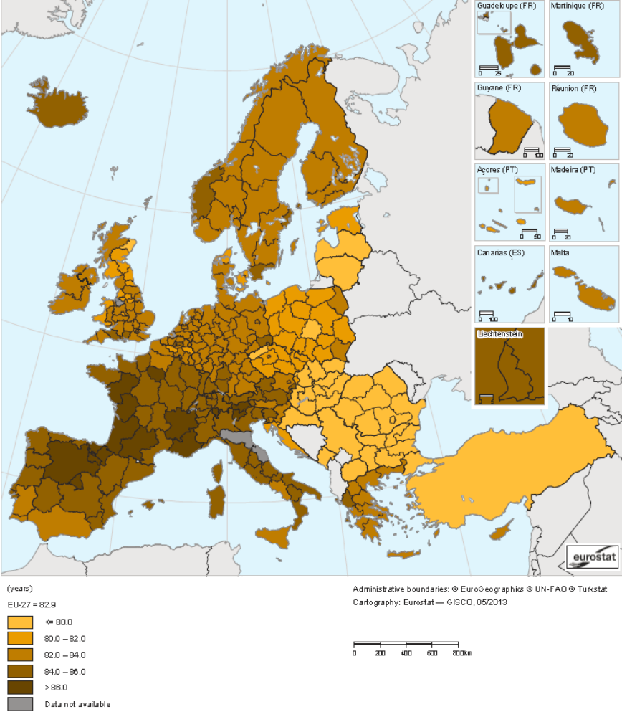
Figure 8 : Life expectancy at birth, female 2011 - Source Eurostat Atlas

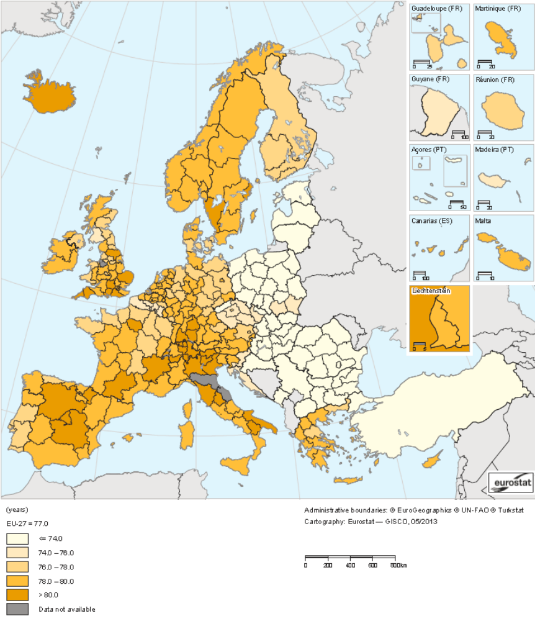
Figure 9 : Life expectancy at birth, Male 2011 - Source : Eurostat Atlas

About the complexity to forecast the evolution of men and women lifespan
France Meslé conclude her presentation about the lifespan difference between men and women by writing: “Although in the long-term it is very likely that the differences in lifespan between men and women at older ages eventually reduce, in the short term the answer is not simple and could be different from one country to another”, a translation to the French version.

The scope of the unisex pricing for pension
What is important to note is that The European Commission clarified that gender discrimination when pricing annuities does not include occupational pension schemes. A European Commission document published on December 22nd states, "Some insurance products, such as annuities, contribute to retirement income. The Directive however only covers insurance and pensions which are private, voluntary and separate from the employment relationship, employment and occupation being explicitly excluded from its scope.". Any annuity payment under occupational pensions is referenced under Directive 2006/54/EC even though the insurance company must pay out the benefit.
Concerns were raised in the HM Treasury discussion that this would lead to a two-tier annuity market and suggestions made that the Equality Act should be extended to ensure gender neutral pricing of annuities for occupational pension schemes.

Conclusion

The consumer point of view

After all this hard work and preparation into the launch of the Gender Directive, it has become clear that consumers are not really benefiting from this law by a great deal. Many people took advantage of the previous legislation before premiums became significantly higher but now, people are looking for ways to save money by trying to lower their premiums.
If you are looking for ways to lower your premium legally, there are several ways you can do this for motor insurance. Insurance providers are offering ‘telematics insurance policies’, where a device is installed into your car and analyses your driving behaviour, especially acceleration and breaking. The device will provide a score based on your driving behaviour; a good driver will be given a good score, which in turn will lower their insurance premium as it indicates less risk to the insurer. Telematics is ideal for those people in high-risk groups such as new drivers, young drivers or less frequent drivers.
Research from Deloitte highlights that “37% of car insurance buyers do not want to use telematics devices to monitor their driving and set car insurance premiums, rising to 58% of 18-24 year olds”. Young drivers are less enthusiastic about the use of telematics to monitor their driving behaviour for various reasons, perhaps because they are newly qualified with less driving experience. More and more consumers are considering telematics because of increased awareness. Previously, consumers have been driven towards car insurance comparison websites as they focus on price. However, with the boost in telematics, they are more interested in premiums based on personal driving habits. Insurers need to promote the benefits of telematics a lot more to increase consumer interest, especially to young motorists. The most obvious way to lower your premiums is to drive a car with a smaller engine as they are in low insurance groups. Whereas cars with larger engines such as sports cars and four by four cars are more expensive to insure.
One important factor to take into account is to get your mileage right. Many people when applying for a policy overestimate their mileage. This leads to a higher premium, as insurance companies believe that the more mileage you have, the more you drive your car and therefore, you are more at risk of having an accident. But, those individuals already in higher risk groups will merely see any impact at all. Be as accurate as possible, trying to calculate how many miles you are likely to drive each year. If you are not sure how many miles you will drive, take a look at your last MOT document will state the figure.
Also, to manage the cost of your motor insurance premium you can get an insurance broker to help you shop around for the best deal. They will insure that that you purchase cover that is adequate for your needs at the best price. Also, going the extra mile, to ensure that your vehicle is secure such as having an alarm or immobilizer fitted as this reduces the risk of theft.
Not many individuals know is that paying premiums in one lump sum instead of instalments can sometimes be cheaper. This not only applies to motor insurance, but other types of insurance cover also. It is important to work out what you really need and think about your coverage. You may be paying for full coverage when you only need the basic services covered so ensure that you are not paying more for a policy than you actually need. If this is easier, write down a list of what you need coverage for and browse for a policy that meets your specifications. Also, extras give you access to additional goods and services but extended extras cover is not cheap. Like coverage, in order to lower your premiums, your extras cover should reflect your needs.
The demand for ‘pay as you drive’ insurance is rapidly increasing. If you only drive your car for one off occasions, rather than having your money tied up in insurance costs, pay as you drive offers you a fairer premium based on how often you drive. Pay as you drive requires an installation of a small black box to your car and it measures your driving distance, how often you drive and when you drive. Pay as you drive will allow you to save money if you avoid driving at night or on narrow country roads. Pay as you drive insurance only requires you to pay for the time you spend using your car. An additional benefit is that the black box acts as a tracker in case your car is stolen.

The difficulty to assess the impact on the premium on the market

Now that the Gender Directive is in force, insurance companies have to take great care in pricing their policies. It is likely that they are experiencing unpredictability in their pricing grounds as this law makes its impact. Insurance companies now have to agree on unisex rates and apply this to all their ranges of insurance products. Companies have to become more competitively aware of competition pricing, constantly having to adjust their current pricing policy and they will have to manage the business mix through effective marketing.
A common rule across a heterogeneous UE
It can be concluded that the outcome of the Gender Directive has so far, had a positive effect in terms of ethics, culture and fairness as a principle. If we take a look at statistical analysis, it is questionable whether it is the right time and right areas in insurance to implement unisex pricing. If consumers believe that the Gender Directive is unfair for motor insurance, they can choose to use telematics being priced on driving behaviour rather than gender. This matter is still debatable for life insurance and we will only know the result of this after further years of study.

At the same time in the US: the ban of unisex pricing for long-term care insurance
EU insurance companies have had to adjust their pricing polices according to the Gender Directive last year. However, it is a different story over in the US. The Gender Directive has not come into effect in the US, but gender-specific pricing is now being adopted in some of the newest generation of long term care insurance policies. Women in the US may experience an increase between 20 and 30 per cent in their policies.
Insurance basics and statistical discrimination
The unisex pricing policy in insurance asks a fundamental question: is it necessary for insurance industry to use statistical discrimination? What rules and limits should we define to it given the world situation in the 21st century (technologies, legacy, ethics, politics…)?
The basics of insurance pricing is the law of large numbers: the average of the results obtained from a large number of trials should be close to the expected value (assuming they are independent and identically distributed). Meanwhile, there is a limit to insurability but it can changes sometimes thanks to the technics, the technology, laws and so on. All these factors would contribute towards making it possible to calculate the loss, the probability, to provide a cover to an affordable premium. Provided it is possible to offer an insurance service, insurance companies must face several problems:

- It is not possible to know exactly and totally each individual risk profile
- Individual risk profiles are different
- The insurance market is not monopolistic
- Given individuals can choose their insurance provider and whether or not to be insured, there is adverse selection
- Moral hazard can modify individual behaviour from the risk adverse to risk takers

The Test-Achats case is an opportunity to think about the segmentation in insurance and the rules and limits in terms of the use of behavioural as well as individuals characteristics factors. In, a period of innovation like telematics, social media, big data, genetics, gender equality is important but it may be better to answer this question on a more global basis.
List of figures:
Figure 1: Timeline of the Gender Directive 5
Figure 2 : The Test-Achats case, from Belgium to the EU - Credits © European Union 2013 5
Figure 3 : Average age of candidates passing their car practical driving test in France - Source : INSEE, enquête nationale transports et déplacements 2008 14
Figure 4 : Age-standardised mortality rates by sex 1979-2010 - Source : Office for National Statistics 24
Figure 5 : UK mortality rates prediction 1980-2030 - Source: Office for National Statistics 24
Figure 6 : Life expectancy at birth time serie and projection by gender in France - Source: INSEE, estimation de population et statistiques de l'état civil et projection de population 2007-2060 25
Figure 7: Gender Gap (Women – Men) in life expectancy at age 65 1998 & 2011 in years - Source : Eurostat [demo_mlexpec] 26
Figure 8 : Life expectancy at birth, female 2011 - Source Eurostat Atlas 27
Figure 9 : Life expectancy at birth, Male 2011 - Source : Eurostat Atlas 28

List of tables:
Tableau 1: Gender-mix French Motor Insurance portfolio - Source: Association Française de l'Assurance 14
Tableau 2: Frequency, severity et pure premium : the motor third-party liability claims by gender and driving experience - Source : Association Française de l'Assurance 15

References

As group insurance schemes and B2B transactions are out of scope of the judgment, this could lead to more products being offered through these routes, allowing those in lower risk groups to access preferential rates
The minimum regulatory profit sharing mechanism is defined in the article A.331-1 to A.331-9-1 of the Code des Assurances
The French Federation of Insurance companies (FFSA) is the leading trade organisation in the insurance market and it holds 90% of the French insurance market
Based on our research on internet between December 2012 and June 2013
Ms Procaccia is a former employee for an insurance company explaining why she feels concerned. She has technical skills to debate about this.
Benoît Hamon, a French politician, a member of the Socialist Party is in charge of social and solidarity economy and consumption in France. See also: http://www.economie.gouv.fr/le-ministere/benoit-hamon for further details
The EU Commission will report on the implementation of the test-Achats ruling in 2014
See also the www.chd.lu Travail à la chambre>Rôles des affaires> page
(3’) ≥ (3) = max[(2)-(1);0]
Evolution du rapport de surmortalité masculine par groupe d’âges en Angleterre-Galles et en France depuis 1950. Source : INED Population & Sociétés N°402 – Juin 2004. Espérance de vie : un avantage féminin menacé? France Meslé Graph 2 page 4
Les écarts d’espérance de vie ne se réduisent pas à tous les âges notamment au Japon. Source : Ined Séminaire INSEE 2012-2013 France Meslé –Différences d’espérance de vie entre les sexes : une réduction inéluctable? Graph page 13
R&A website: http://www.riskandanalysis.com
Gender Directive Conference website: http://genderdirective.actuariacnam.net/index.php/en/
Profile: http://www.linkedin.com/profile/view?id=228775395&trk=nav_responsive_tab_profile
Cass Business School website: https://www.cass.city.ac.uk
Diamond. (2012) Young women unprepared for change in gender law [Online] Available at: http://www.diamond.co.uk/press-releases/14092012/ [Accessed July 2013]
Equity and Human Rights Commission. (2012) What is Discrimination? [Online] Available at: http://www.equalityhumanrights.com/advice-and-guidance/further-and-higher-education-providers-guidance/key-concepts/what-is-discrimination/ [Accessed July 2013]
Crayshaw-Jones, L. (30/01/2013) Impact of EU gender directive hits enhanced annuity rates [Online] Available at: http://123annuityrates.co.uk/impact-of-eu-gender-directive-hits-enhanced-annuity-rates-1399/ [Accessed August 2013]
Davies, S. (October 2013) European Court of Justice gender directive [Online] Available at: http://www.gocompare.com/gender/2013[Accessed October 2013]
Oxera. (2011) Gender and insurance: impact on EU consumers of a ban on the use of gender [Article] Available at: http://www.oxera.com/Oxera/media/Oxera/downloads/Agenda/Gender-in-insurance-market.pdf?ext=.pdf [Accessed August 2013]
Kenny, P. (09/12/13) Women hit hardest by new EU car insurance law [Online] Available at: http://www.rte.ie/news/money/consumer/2013/0106/361493-women-face-huge-hikes-in-car-insurance/ [Accessed December 2013]
Loderick, N. Confused.com. (19/10/2012) Why is the EU interfering with our car insurance prices? [Online] Available at: http://www.confused.com/car-insurance/articles/why-is-eu-interfering-in-britain-uk-car-insurance-market [Accessed July 2013]
(21/03/2013) [Accessed june 2013] Post - article title : Gender Directive : Continental Drift Author : Francesca Nyman http://www.postonline.co.uk/post/feature/2314298/gender-directive-continental-drift
Tiger.co.uk. (19/04/13) Blog: Young Women Bear The Brunt Of EU Change [Online blog] Available at: http://www.tiger.co.uk/blog/young-women-bear-the-brunt-of-eu-change/ [Accessed September 2013]
EUR-Lex legislation. (2004) THE COUNCIL OF THE EUROPEAN UNION [Online] Available at: http://eur-lex.europa.eu/LexUriServ/LexUriServ.do?uri=CELEX:32004L0113:EN:NOT [Accessed September 2013]
http://eur-lex.europa.eu/LexUriServ/LexUriServ.do?uri=OJ:C:2011:130:0004:01:EN:HTML
http://eur-lex.europa.eu/LexUriServ/LexUriServ.do?uri=OJ:C:2012:011:0001:0011:EN:PDF
http://eur-lex.europa.eu/LexUriServ/LexUriServ.do?uri=OJ:C:2010:083:0013:0046:en:PDF
Legislation.gov.uk. (2010) Equality Act 2010 Legislation [online] Available at: http://www.legislation.gov.uk/ukpga/2010/15/contents [Accessed August 2013]
Legifrance. (2007). LOI n°2007-1774 du 17 décembre 2007 [Online] Available at: http://www.legifrance.gouv.fr/affichTexte.do?cidTexte=JORFTEXT000017661897&dateTexte=&categorieLien=id[Accessed August 2013]
Legifrance. (2012) Arrêté du 18 Décembre 2012 [Online] Available at: http://www.legifrance.gouv.fr/jopdf/common/jo_pdf.jsp?numJO=0&dateJO=20121220&numTexte=12&pageDebut=20091&pageFin=20091 [Accessed September 2013]
Association Française de l’assurance. (2007) Dernières publications [Online] Available at: http://www.associationfrancaisedelassurance.fr/ [Accessed September 2013]
Observation et Statistiques publications. (2010) Enquête nationale transports et déplacements (ENTD) 2008 [Online] Available at: http://www.statistiques.developpement-durable.gouv.fr/sources-methodes/enquete-nomenclature/1543/139/enquete-nationale-transports-deplacements-entd-2008.html [Accesses November 2013]
http://www.dailymotion.com/video/x128fjs_catherine-procaccia-senateur-du-val-de-marne-tarifs-d-assurances-des-conductrices_news
SÉNAT. (2012) Hausse de tarification des assurances automobiles pour les conductrices [online] Available at: http://www.senat.fr/questions/base/2012/qSEQ12110237S.html[Accesses November 2013]
MeAC (2011) [Accessed June 2013]. http://www.eaccessibility-progress.eu/country-profiles/belgium/equality-anti-discrimination/
[Accessed June 2013] http://cet.lu/wp-content/uploads/2010/08/19juin20121.pdf
[Accessed June 2013] http://www.chd.lu/wps/PA_RoleEtendu/FTSByteServingServletImpl/?path=/export/exped/sexpdata/Mag/182/162/118611.pdf
[Accessed June 2013] http://www.commassu.lu/upload/files/336/Circ12_10.pdf
Institute and Faculty of Actuaries. (06/10/10) EU gender equality legislation could lead to inequality in provision of insurance products [Online] Available at: http://www.actuaries.org.uk/news/press-releases/articles/eu-gender-equality-legislation-could-lead-inequality-provision-insuranc [Accessed August 2013]
Gallagher, J. (23/04/12) Men set to live as long as women, figures show [Online] Available at: http://www.bbc.co.uk/news/health-17811732 [Accessed July 2013]
Taylor Patterson. (27/11/12) EU gender directive to benefit pensions for women [Online] Available at: http://sippssas.taypat.co.uk/eu-gender-directive-to-benefit-pensions-for-women [Accessed July 2013]
Selby, T. (17/01/12) EU gender directive does not apply to occupational pensions [Online] Available at: http://www.moneymarketing.co.uk/pensions/eu-gender-directive-does-not-apply-to-occupational-pensions/1044508.article [Accessed July 2013]
dwf. (14/11/12) Gender Directive - Insuring Equality [Online] Available at: http://www.dwf.co.uk/news/view-point/gender-directive-insuring-equality/ [Accessed August 2013]
Deloitte. (01/05/13) Deloitte research highlights consumers’ attitudes to telematics [Online] Available at: http://www.deloitte.com/view/en_GB/uk/industries/financial-services/0e658a8c1bf5e310VgnVCM2000003356f70aRCRD.htm [Accessed September 2013]
Levine. J. (25/07/13) Gender-based Pricing Comes to Long Term Care Insurance [Online] Available at: http://www.chicagotribune.com/news/local/suburbs/highland_park_deerfield/community/chi-ugc-article-gender-based-pricing-comes-to-long-term-care-2013-07-25,0,7783400.story [Accessed November 2013]

